Navigating the Event:
- Login to Eventtus with your credentials.
- You will be redirected to your Eventtus profile, under “My Events” you will find “Board of Trustees Meeting October 2021” click on the Event and you will be redirected to the Event home page
- Click on “Open Virtual Event” at the right corner of the screen that appears as follows:

- You will be redirected to the following main event page where you can navigate through all event tabs

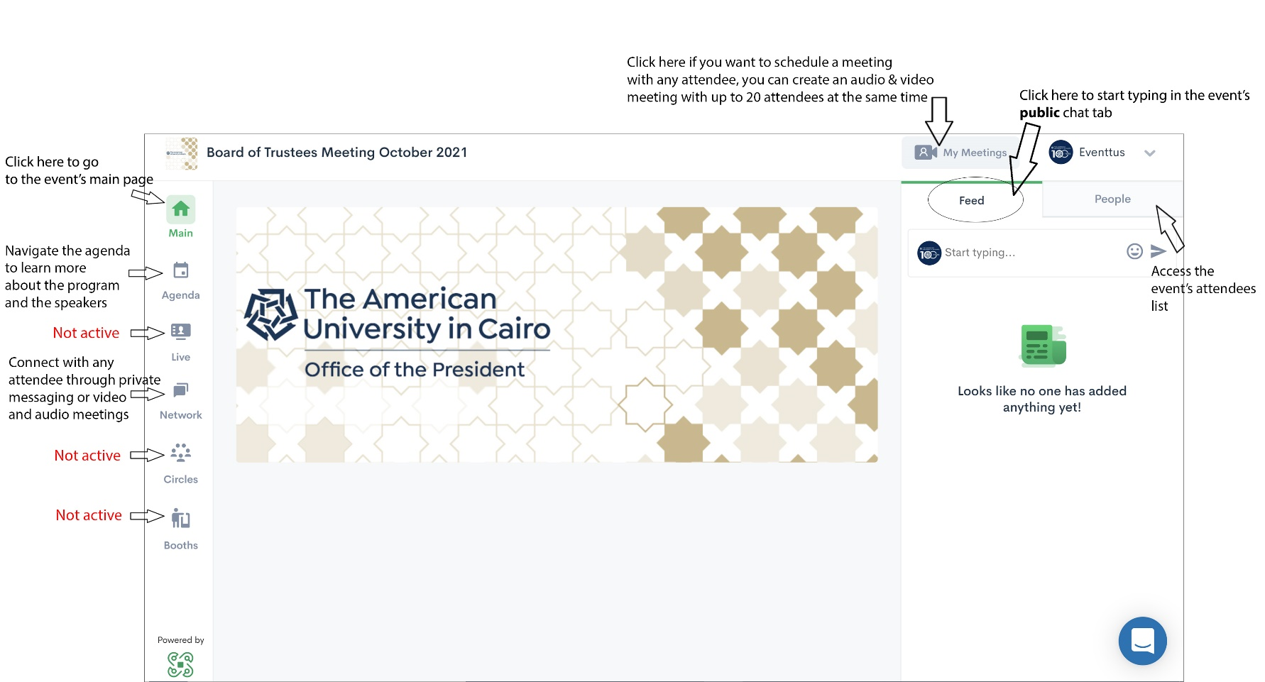
Disclaimer: if you already registered on AUC Conferences app for 2020’s board meeting, please use same credentials to login to Eventtus
Posting and Networking:
Eventtus enables you to connect with specific attendees through private audio and video meetings or messages.

- Click on the “Network” tab at the left corner of the screen.
- If you wish to video or audio chat with any of the attendees, you can click on “My Meetings” at the top right corner of the screen
- Start filling in all the needed fields (choosing attendees, start time, end time). You can also share your screen with all meeting participants.
- You can also send private messages to attendees by clicking on the message icon next to that attendee’s name.

- You can also type in the event public chat tab visible for all event attendees at the right corner of the screen.

