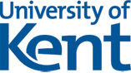
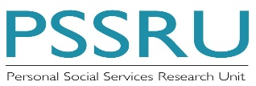
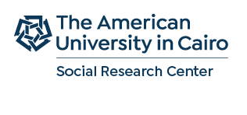

Addressing Population-Ageing
in the Middle East and Sub-Saharan Africa

The Social Research Center at the American University in Cairo held a workshop on Population Aging in the Middle East and Sub-Saharan Africa, 9-10 April 2019. The workshop was a collaborative activity with University of Kent, United Kingdom (Professor Shereen Hussein); the American University in Beirut, Lebanon (Professor Abla Sibai and Maya Chahine); and the African Center for Population and Health, Kenya (Isabella Aboderin). It was sponsored by the Social Research Center at the AUC and the University of Kent, GCRF partnership funding.

The workshop aimed to bring to the forefront of policy debate the scale and implications of population aging in the region with all its social, economic and health dimensions through a mutli-sectorial forum of discussion. During the workshop researchers, national and international policymakers and Non-Governmental Organizations’ (NGOs) were able to share evidence-based research and examples of innovative activities and policy developments with the aim of planning efficient and effective interventions to secure the welfare of older persons and their families in the Arab region and Sub-Saharan Africa.

The workshop included 6 sessions that addressed three main dimensions
- The international and regional agendas and strategies for population aging and older persons including:
  - World health Organization Head Quarter and their general directions in the area of population aging and their relationship to the Sustainable Development Goals
  - The launching of the Aging Population Strategy in the Arab Region 2019-2029 by the Arab league in collaboration with the UNFPA/ASRO Regional Office
- The national experiences in the Arab and Middle Eastern Countries including
  - A comparative overview of population ageing in the region
  - Population aging in Egypt, exploring the experience of older persons
  - Activities of academic institutes in creating knowledge and capacity in meeting the demand of long term care including the National Institute of Longevity and Elderly studies, Beni Sweif University and Faculty of Nursing, Mansoura University.
  - The activities of national and international NGOs including KEMET, Egypt, and HelpAge International, Jordon, focused on older persons’ inclusion and wellbeing.
  - Population aging in Lebanon with emphasis on the activities of The center for Studies on Aging and Senior University in American University in Beirut
  - Population aging in Turkey with a focus on Long term care costs and their policy implications.
- Setting research priorities and building research coalition in the area for Population Aging to support policy
This two-day workshop provided a unique opportunity to share knowledge, perspectives and potential outcomes between a diverse group of audience, capitalizing on the diverse expertise brought by policymakers, researchers and NGOs to the discussion. The workshop concluded by a commitment to pursue collaborative research and intervention activities aimed at enhancing the lives of older people in the region. The core team will consider future funding opportunities to allow a multi-sectoral, multi-disciplinary co-produced activities that might investigate culturally-sensitive and context-specific interventions aimed at enhancing the wellbeing and quality of life of older persons and their families.

