To make the print shop order for this jobs:
Digital
Photocopy
Scanning
Plastic binding
Hard cover binding

Please follow these steps:
Web site:
https://www4.aucegypt.edu/printshop/

1- Login by user e-mail and email password, if you don’t have access please send e-mail to Ms. Marian Ramzy m_ramzy@aucegypt.edu to create access and send in this e-mail this data (full name – user e-mail- full department name – ext.)
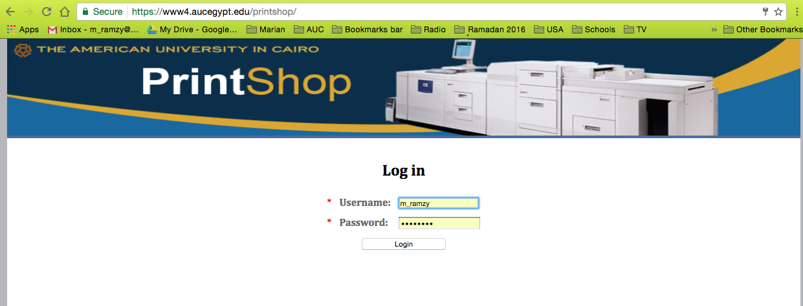

2- Fill the job data
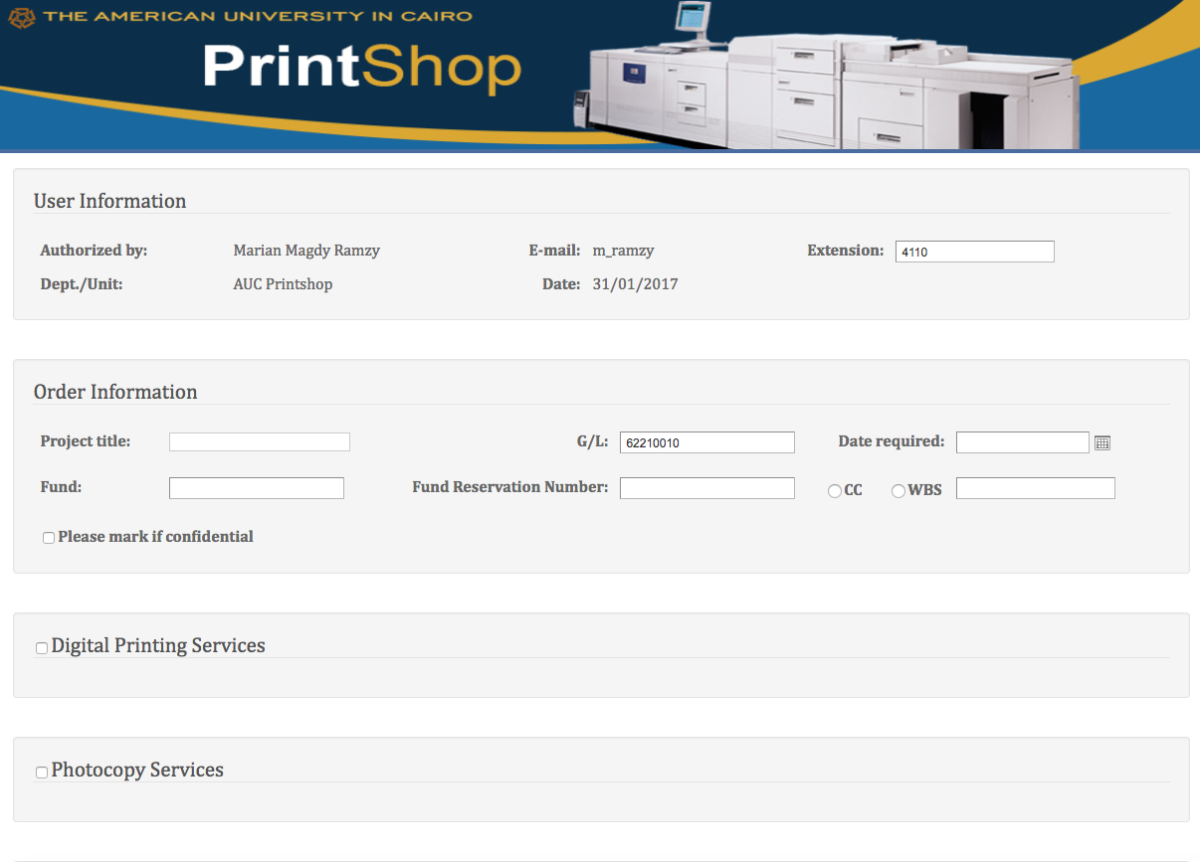

Choose Cost center or WBS

Create fund reservation on SAP
Ex. 10100000

3- choose you job (Digital – Photocopy -Scanning -Plastic binding -Hard cover binding)

Digital:
Choose the file

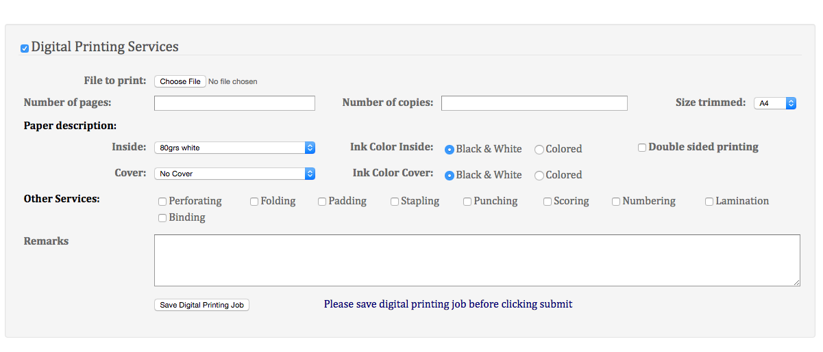

Save digital job

Photocopy:
Send the material

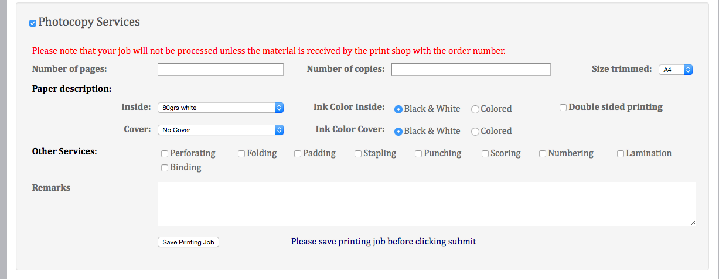

Save Photocopy job

Plastic binding:
Quantity of copies
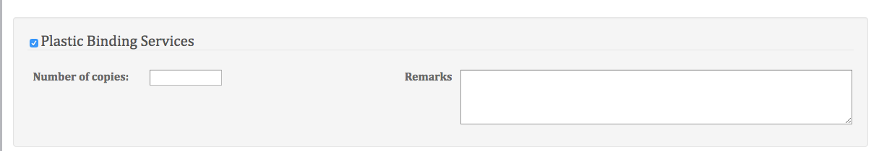

Hard cover and scanning as plastic binding

- After you save the job you’ll find this screen
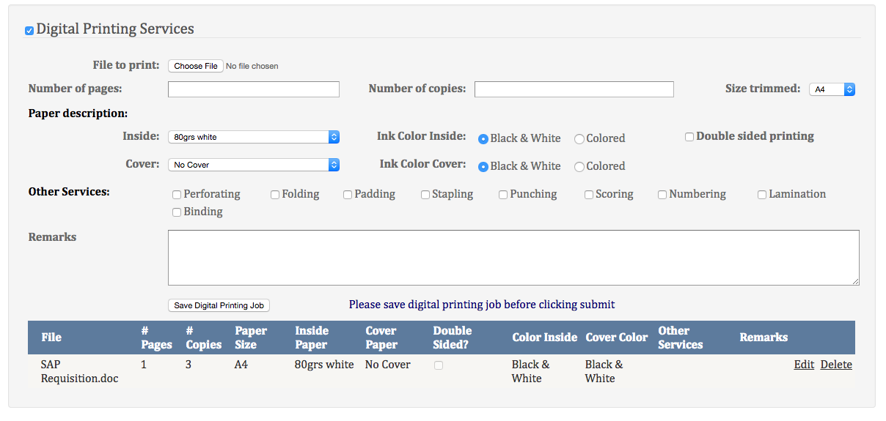

This your job saved

- If you need to add many jobs you must fill all job description and save the job.
- After you finished all jobs you must press submit in the end of the page.

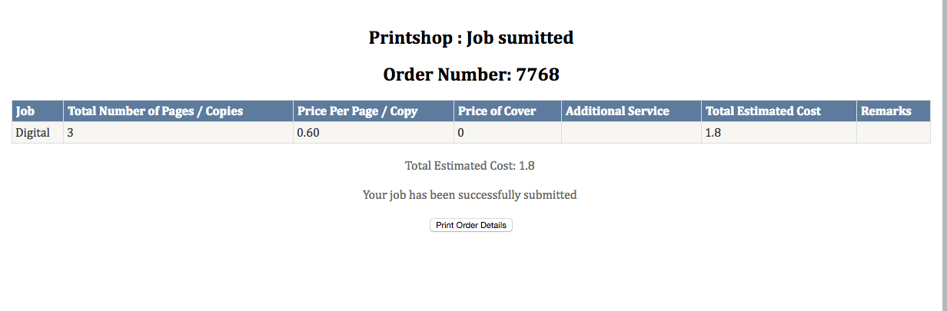
- Then the new page open with number of order with total price.

- You’ll receive e-mail from the system include all job details and total estimated price
