LLT Policy on Copyright

Approving Authority: LLT Dean’s Council
Date Adopted: 4 October 2015
Last Reviewed: 4 October 2015
Prepared by: Laura Bradford, Mark Muehlhaeusler, Jayme Spencer, Russell Stephens, Peter Philps, Anchalee Panigabutra-Roberts

- Policy Purpose

This policy provides guidance on copyright compliance for library staff and patrons. Under U.S. Law, the existence of a copyright policy is a statutory requirement, so that the Library may partake some of the exceptions to the exclusive rights of copyright holders. It is also a requirement that accurate information on copyright and compliance is made available to patrons. This policy aims to fulfill both requirements.

- Policy Statement

- Legal framework

The American University in Cairo (AUC) is an American institution incorporated in Delaware, with offices in New York. The University and its Library are physically located in Cairo, Egypt.

AUC’s School of Libraries and Learning Technologies (LLT) adheres to U.S. copyright law, as laid out in title 17, U.S.C. (http://copyright.gov/title17/), and Egyptian copyright law (http://www.wipo.int/wipolex/en/details.jsp?id=1301), where appropriate.

The School of Libraries and Learning Technologies is committed to comply with the statutory requirements of U.S. law, through:

- the formulation and publication of policies and guidelines relating to intellectual property and copyright
- the public display of required warnings and notices
- the appointment of designated staff members at AUC, who will receive legal notices.

Details of LLT’s procedures are set out in the section on compliance, and the guidelines below.

As a matter of policy, and in fulfillment of certain legal requirements, the School of Libraries and Learning Technologies promotes an understanding of intellectual property law. It educates members of AUC about their rights and obligations under current and applicable laws, through:

- linking to the text of applicable copyright laws
- direct user education, such as workshops or presentations
- the publication of informational material on its website
- the public display of required warnings and notices
- linking to further tools and resources
- offering advice (though not legal advice) and guidance upon request

LLT asserts its right to make reproductions of copyrighted materials within the limits set by law. In particular, the limitations on the exclusive rights of copyright holders set out in title 17, U.S.C, sec. 107 (Fair Use), sec. 108 (Reproduction by Libraries and educators), and sec. 110 (cf. TEACH act) provide the legal basis for many of LLT’s practices. An overview of the legal framework is provided in Circular 21, published by the U.S. Copyright Office.

- Compliance

1)
For the purpose of compliance with the requirements of the Technology, Education, and Copyright Harmonization (TEACH) Act (Sec. 110(2)(d)), the School of Libraries and Learning Technologies herein “institutes policies regarding copyright, provides informational materials to faculty, students, and relevant staff members that accurately describe, and promote compliance with, the laws of the United States relating to copyright, and provides notice to students that materials [...] may be subject to copyright protection.”

2)
In compliance with Sec. 108(f), the Library will post public notices on public print stations, self-service photocopiers, and other reproduction equipment that the making of a copy may be subject to the copyright law. In accordance with the ALA-RUSA guidelines (http://www.ala.org/rusa/resources/guidelines/languagesuggested), these notices shall contain the following text:

Notice: The copyright law of the United States (Title 17 U.S. Code) governs the making of photocopies or other reproductions of copyrighted material. The person using this equipment is liable for any infringement.

3)
in compliance with 37 C.F.R. § 201.14, the Library will post a Display Warning of Copyright prominently in all locations where orders for reproductions are accepted. The Library will also print an Order Warning of Copyright on all forms that are used to order reproductions. The Warning shall consist of the following text, which will be reproduced verbatim, and in accordance with the size requirements laid out in the section cited above.

Notice: Warning Concerning Copyright Restrictions

The copyright law of the United States (title 17, United States Code) governs the making of photocopies or other reproductions of copyrighted material. Under certain conditions specified in the law, libraries and archives are authorized to furnish a photocopy or other reproduction. One of these specified conditions is that the photocopy or reproduction is not to be “used for any purpose other than private study, scholarship, or research.” If a user makes a request for, or later uses, a photocopy or reproduction for purposes in excess of “fair use,” that user may be liable for copyright infringement. This institution reserves the right to refuse to accept a copying order if, in its judgment, fulfillment of the order would involve violation of copyright law.
4)
If and when audiovisual materials are prepared for digital distance delivery to AUC classes under the provisions of the TEACH Act (Sec. 110), LLT will adhere to the conditions set out in the statute. Several checklists of these conditions are available.

- Copyright information

Disclaimer: The following information about copyright does NOT (or does not fully) apply to these categories of materials:

licensed works. Licenses are contracts, and may include terms that are more restrictive than copyright law. In online databases, online journals, e-books, and websites, one can often find the license terms under “about” or “terms of use”.

publicly licensed works, or works published on open access. This type of material is usually clearly marked with a “creative commons” icon, or a similar tag. The content is freely accessible, but some restrictions may apply, such as mandatory attribution.

works for which the copyright term has expired. For example, books published in prior to 1923 are now in the “Public Domain” in the United States. In Egypt, the economic rights of authors expire 50 years after the death of the author.

works created by or for the federal government of the United States, which are exempt from copyright, and are in the Public Domain.

- What is Copyright?

Basic information:
http://copyright.gov/circs/circ01.pdf
Detailed information:
http://copyright.columbia.edu/

What one commonly refers to as “copyright” is actually a bundle of several exclusive rights, including the right to:

- reproduction (such as copying or reprinting)
- preparation of derivative works (such as translations, or adaptations)
- distribution
- display and
- performance

These rights are automatically held by creators of “original works of authorship”, as soon as the work is fixed in any tangible form of expression (written down, saved or recorded). Under U.S. law, creators do not have to register their works in order to benefit from copyright.

These types of material can be protected by copyright:
- printed books or journal articles  - handwritten texts  - photographs  - sound recordings  - video recordings | - visual artworks  - computer software  - web pages  - multimedia works

Since materials are automatically protected by copyright, Library patrons are advised to treat all Library materials as potentially protected.

- Limitations on copyright

U.S. Copyright law grants libraries and educators certain rights to reproduce copyrighted materials without seeking permission. These limitations on copyright are outlined in Circular 21 published by the US Copyright Office (http://copyright.gov/circs/circ21.pdf).

One of the most important limitations on copyright is Fair Use (http://fairuse.stanford.edu/). In making their Fair Use determinations, we encourage users to refer to publicly available tools (http://librarycopyright.net/resources/fairuse/), or to seek advice from Library staff.

- Penalties
AUC Libraries and Learning Technologies cautions AUC members and visitors against copyright infringement, and advises them to refrain from making unlawful use of copyrighted material in their work.

Serious cases of copyright infringement may incur severe penalties. The remedies for copyright infringement under U.S. law are laid out in sec. 501-513 of title 17, U.S.C. (http://copyright.gov/title17/92chap5.html).

- Guidelines

The following sections will serve as general guidelines for Library patrons and staff in their daily work. Separate guidelines are given for each type of activity and type of material.

Copyright &Teaching: please refer to the Know Your Copy Rights site (http://www.knowyourcopyrights.org/) and guide (http://www.knowyourcopyrights.org/bm~doc/kycrbrochurebw.pdf), prepared by the Association of Research Libraries. Both contain helpful overviews and decision charts to help you determine the lawful uses of different material types in a classroom setting.

1.
Printing
General
Unmediated (=self-service) printing is available in the AUC Library building at microform readers and print stations.

A copyright notice must be displayed prominently near the equipment (use the notice format cited above, “Compliance”, sec. 2).

Guidelines for patrons
As noted above, all material that is accessible in the Library is potentially protected by copyright, or subject to the terms of a license. Hence,

- determine the lawful uses of the material which you intend to print or copy.
- for licensed materials (databases, e-books, articles in electronic journals, etc...): please refer to the license terms under “help” or “terms of use”; in case of doubt, request assistance from eresrouces@aucegypt.edu.
- for materials without an explicit license (some microforms, websites, images, etc.), you may print the following (these are minimum guidelines):
  - A chapter from a book,
  - An article from a periodical or newspaper,
  - A short story, short essay or short poem,
  - A chart, graph, diagram, drawing, cartoon, or picture from a book, periodical or newspaper.

2.
Mediated copying (BOOKS, JOURNALS, & other physical materials)
General
Mediated copying occurs when an AUC staff member performs the copying of materials for a library patron (faculty, student, staff, or visitor).

Please note that these guidelines only apply to:

- printed books, print journals, and other physical materials AND
- which are still protected by copyright (see ‘copyright term’ above) AND
- which are not subject to the terms of a license as part of a purchase contract or lease agreement.

Guidelines for patrons
- patrons must submit a separate request form for each copy job.
- the request form will carry a copyright notice (see above, “Compliance”, sec. 3)
- requests for copying in excess of the legal limit will not be processed

Guidelines for staff
- require a separate request form for each copy job
- ensure that the request form carries a copyright notice (above, “Compliance”, sec. 3)
- you may make for a patron, one (1) copy of the following:
  - A chapter from a book,
  - An article from a periodical or newspaper,
  - A short story, short essay or short poem,
  - A chart, graph, diagram, drawing, cartoon, or picture from a book, periodical or newspaper.

House of Representatives. report on Copyright Law Revision
Report #94-1476

- attach a copy of the following statement to the copied work:

Notice: This work may be protected under US copyright Law (Title 17, USC), which governs reproduction, distribution, public display, and certain other uses of protected works. Uses may be allowed with permission from the rights holder; or if the copyright on the work has expired, or if the use is “fair use” or within another exemption. The user of this work is responsible for determining lawful uses.

3.
Print Reserves (PRINTED BOOKS only)

Upon request by AUC instructional faculty and staff, AUC Libraries will place physical copies of materials on reserve. Certain limitations apply.

Guidelines for faculty

    - For books in the Library's collection:

use the online form: https://forms.aucegypt.edu/lib/coursereserve/resrform_2.htm

    - For books provided by AUC instructors:

please complete a request form, and submit a hard copy along with your books to a member of the circulation staff of the Main Library. Please note:

- You must provide clean copies of material to be placed on Reserve.

- If you place copies on Reserve, you affirm that all copies have been made in compliance with U.S. and international copyright laws. In accepting copies for Reserve, the AUC Library assumes that any copies submitted for reserve have been made in compliance with U.S. and international copyright law.

- The following materials will not be placed on Reserve:
  - Photocopies created to replace or substitute for anthologies, compilations, or collective works.
  - Photocopies of works intended to be “consumable” in the course of study or teaching, such as workbooks, exercises, standardized test booklets, etc.
  - Photocopies of entire books (unless the original is in the public domain, or carries a public license).

4.
Electronic Reserves (Books & Articles only)

Upon request by AUC instructional faculty and staff, AUC Libraries may digitize and place electronic copies of materials on reserve. Strict limitations apply.

Please note that materials which are already available in electronic format (such as e-books, or articles in databases) can often not be placed on reserves due to licensing restrictions. Instructors are advised to provide hyperlinks to these types of materials [see notes below].

Guidelines for faculty

- Use the online form: https://forms.aucegypt.edu/lib/coursereserve/resrform_2.htm

- For books in the Library's collection:

- Books in the public domain (e.g. published in the U.S. prior to 1923) can be digitized entirely.
- Books that are still protected by copyright: You may request one chapter, or up to 10% of the total number of pages of a print book.
- NB: In recent U.S. case law, the limitations of electronic reserves have been severely tested. A final determination of what constitutes a ‘safe’ limit for electronic reserves has not been reached. The Library reserves the right to digitize only such quantities as it deems safe.

- For books not held by the Library:

  - You may request that a copy be bought by the Library. Preference will be given to e-books, which can be linked to syllabi.

NOTE:

E-books cannot be placed on reserve. However, instructors may provide a link to particular e-books to their students via blackboard or email. A stable URL should be used to link to e-books:
- In the Library catalog, search for the book
- Open the full record by clicking on the title, or the link on the right
- at the very end of the record, click the link “Permanent URL for this record”.
- The page will reload. Copy the URL that now appears in the browser bar.
- Paste this stable URL into an email, or blackboard page.

5.
Audiovisual Material: DVD/CD Reserves

DVDs and CDs may be placed on reserves. Please follow the guidelines for print reserves above (no. 3).

6.
Audiovisual Material:

A. In-classroom use:

In general, performance or display of a work by instructors or pupils in the course of face-to-face teaching activities of a nonprofit educational institution, in a classroom or similar place devoted to instruction, is not an infringement of copyright. Instructors may display lawfully obtained copies of works, or portions thereof, as part of their classroom presentation without obtaining permission from any rights holder.

B. Streaming (Distance use of copyrighted materials)

Guidelines for Faculty
Instructors may wish to present copyrighted material as part of a distance (electronically-delivered) course. This also is not a copyright violation, provided that the instructor complies with the following:

1. The work transmitted must be one of the following:
- A performance of a nondramatic literary work; or
- A performance of a nondramatic musical work; or
- A performance of any other work, including dramatic works and audiovisual works, but only in “reasonable and limited portions”; or
- A display in an amount comparable to that which is typically displayed in the course of a live classroom session.

2. The work is not:
- marketed primarily for performance or display as part of a digitally transmitted mediated instructional activity.
- a textbook, course pack, or other material in any media which is typically purchased or acquired by students for their independent use and retention.

3. The performance or display is made by, at the direction of, or under the actual supervision of an instructor as an integral part of a class session offered as part of the regular curriculum; and
- the performance or display is directly related and of material assistance to the teaching content of the transmission
- the transmission is made solely for, and, to the extent technologically feasible, the reception of such transmission is limited to—
  - students officially enrolled in the course for which the transmission is made; or
  - officers or employees of governmental bodies as a part of their official duties or employment

4. In the case of digital transmissions, the method of transmission:
- applies technological measures that reasonably prevent:
  - the retention of the work in accessible form by recipients of the transmission from the transmitting body or institution for longer than the class session; and
  - the unauthorized further dissemination of the work in accessible form by such recipients to others.
- does not interfere with technological measures used by copyright owners to prevent such retention or unauthorized further dissemination;

C. Streaming outside of the classroom (e.g. for a homework assignment)

If the contemplated transmission does not comply with the above, there may be strict limitations on what can be done. Please use the chart below to identify the process that you need to follow.

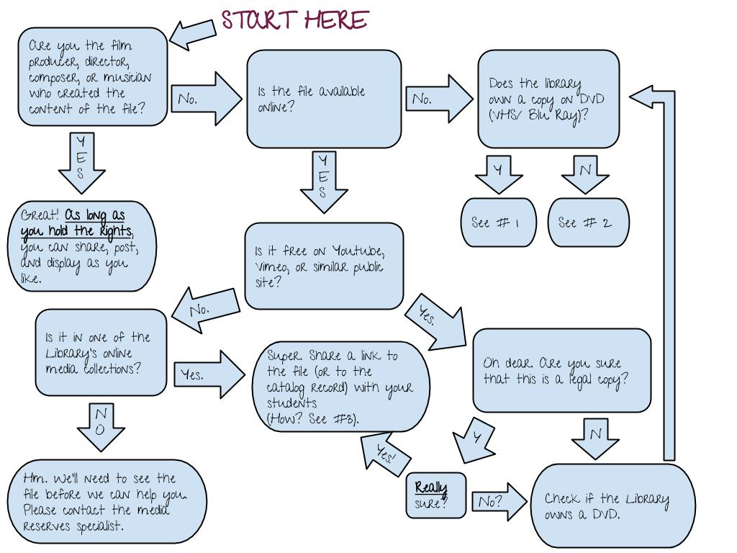

Note #1
(copy in library)
The Library may be able to digitize (within the limits permitted by law), and stream the audiovisual material. Note that there may be restrictions on the quantity that can be digitized. Please contact a media reserves specialist at reserves@aucegypt.edu.

Note #2
(no copy held)
The library will seek to acquire a copy of the material through its regular vendors. Preference will be given to a streaming license. If such a license is not available for Egypt, a DVD copy may be bought, digitized (within the limits permitted by law), and streamed. Please contact a media reserves specialist at reserves@aucegypt.edu.

Note #3
For this option ONLY: You may provide students with a link through any medium. Links do not need to be shared in a password-protected environment. Use a stable URL to the resource.

- For films in one of the Library’s media collections: Use a stable URL to the catalog record, Thus:
- In the Library catalog, search for the title of the film.
- Open the full record by clicking on the title, or the link on the right (“Full record”)
- at the very end of the record, click the link “Permanent URL for this record”.
- The page will reload. Copy the URL that now appears in the browser bar.
- Paste this stable URL into an email, or blackboard page.

- In Youtube, go to “Share”, & use the URL starting with “youtu.be…”.
- On other sites, locate the “share” function (if available), and use ULR provided.

Guidelines for staff

- Media held in AUC collections
  - Can the material be digitized under sec. 110 (TEACH Act)? ( use checklist)

If YES: Proceed as follows:
      - Keep a copy of the checklist for files
      - Digitize
      - Add copyright warning
      - Keep all files on secure server
      - Link to file from reserve system or Blackboard
      - Restrict access to instructor and students only
      - Restrict to class meeting time
      - Delete file within reasonable interval after use

IF NO: [next]

- Can the material be digitized under sec. 107 (Fair Use)? (use online tool)

If YES: Proceed as follows:
      - Keep a copy of the Fair Use evaluation for files
      - Digitize
      - Add copyright warning
      - Keep all files on secure server
      - Link to file from reserve system or Blackboard
      - Restrict access to instructor and students only
      - Delete file within reasonable interval after use

If NO: [next]

  - Is a streaming license available?

If YES: Purchase streaming license.
If NO: Notify instructor. Attempt to locate alternative.

- Media not held in AUC collections

  - Is a streaming license available?

If YES: Purchase streaming license
If NO: Purchase DVD. Revert to procedure for regular holdings

