Graduate Studies

[Thesis Title]

A THESIS SUBMITTED BY
[Student name]

TO THE

[Graduate Program Name]

SUPERVISED BY

[Name of Thesis Faculty Supervisor(s)]

[Date]

in partial fulfillment of the requirements for the degree of
[Graduate program name]

Declaration of Authorship
I, [Student name], declare that this thesis titled, “[Thesis title]” and the work presented in it are my own. I confirm that:

- This work was done wholly or mainly while in candidature for a research degree at this University.
- Where any part of this thesis has previously been submitted for a degree or any other qualification at this University or any other institution, this has been clearly stated.
- Where I have consulted the published work of others, this is always clearly attributed.

- Where I have quoted from the work of others, the source is always given. With the exception of such quotations, this thesis is entirely my own work.
- I have acknowledged all main sources of help.
- Where the thesis is based on work done by myself jointly with others, I have made clear exactly what was done by others and what I have contributed myself.

Signed:

Date:

STUDENT TO INSERT HERE THE PAGE WITH THE SIGANTURES OF THE THESIS DEFENSE COMMITTEE

Abstract
[Body text]

Acknowledgements
[Body text]

Contents

Declaration of Authorship i
Abstract iii
Acknowledgements iv
List of Figures/Images/Sound Files vi
List of Tables vii
List of Abbreviations viii
List of Symbols ix
Chapter 1 1
Title of chapter 1 1
1.1 [Header 3] 1
Chapter 2 2
[Title of chapter 2] 2
2.1 [Header 3] 2
2.2 [Header 3] 2
Chapter X 3
[Conclusion] 3
References 4
Appendix 1 4
Appendix 2… 4

List of Figures/Images/Sound Files

FIGURE/Image/Sound File X: Caption 11

List of Tables

TABLE X: Table title 11

List of Abbreviations

AoD Angle of Departure

List of Symbols

λ_{c} carrier wavelength

Chapter 1

Title of chapter 1

1.1 [Header 3]
Body text

Chapter 2

[Title of chapter 2]

Body text

2.1 [Header 3]
Body text

2.2 [Header 3]
Body text

Chapter X

[Conclusion]

Body text

References

Appendix 1

Appendix 2…

Important Notes:
- EQUATIONS AND SYMBOLS MUST BE INSERTED from the insert tab.
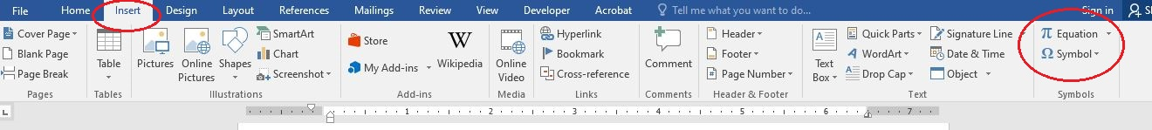

- Figures should be inserted from the references tab.
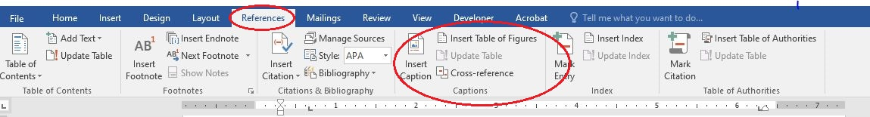
FIGURE X: Figure caption

Table X: Title of the table
Column Header
Body text

